**PLOTS: Input State Linearization**

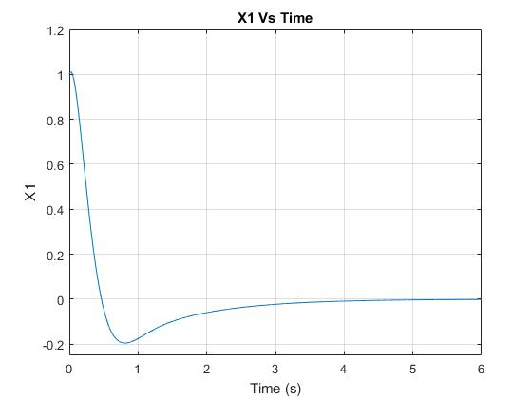

Figure 1: Plot of X1 Vs Time

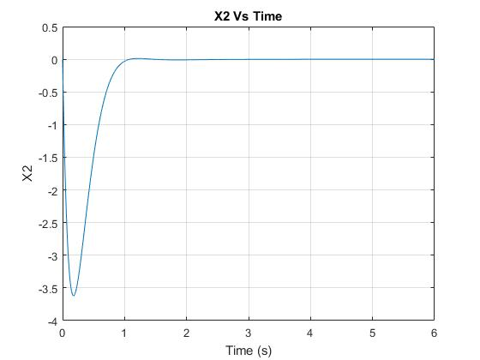

Figure 2: Plot of X2 Vs Time

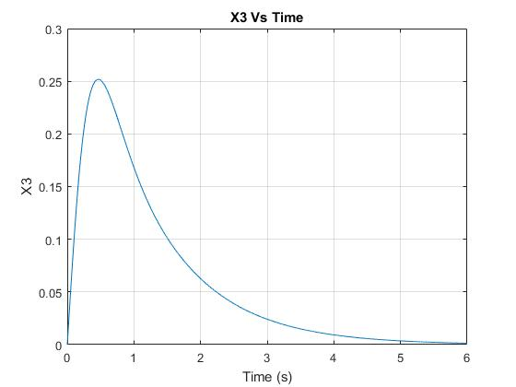

Figure 4: Plot of X3 Vs Time

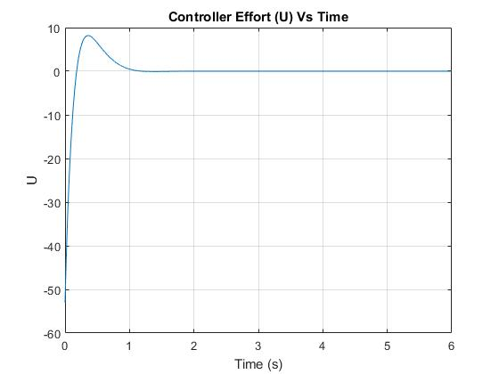

Figure 4: Plot of Controller Effort (U) Vs Time

**PLOTS: Input Output Linearization**

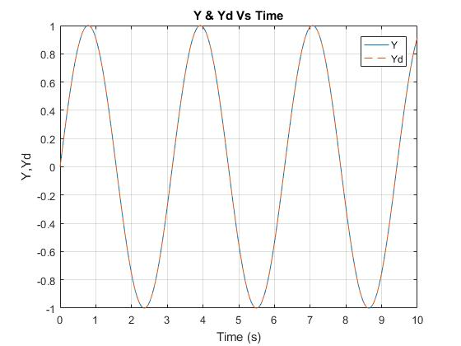

Figure 5: Plot of Y and Yd­ vs Time

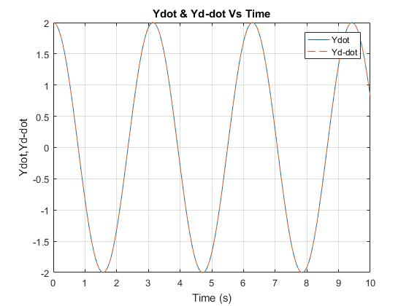

Figure 6: Plot of Ẏ & Ẏd Vs Time

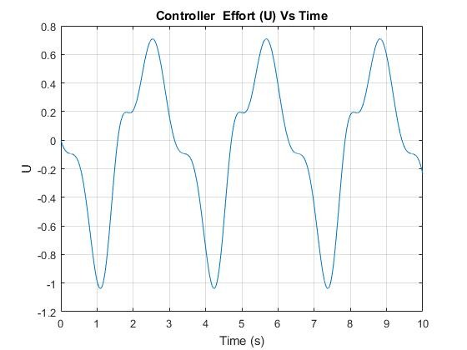

Figure 7: Plot of Controller Effort (u) Vs Time

**Answers to Specific and satisfying the giving conditions**

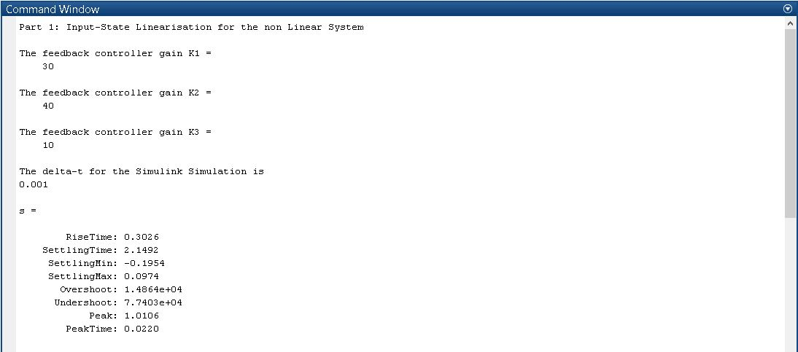

Figure 8: Command Window for Solutions for question 1

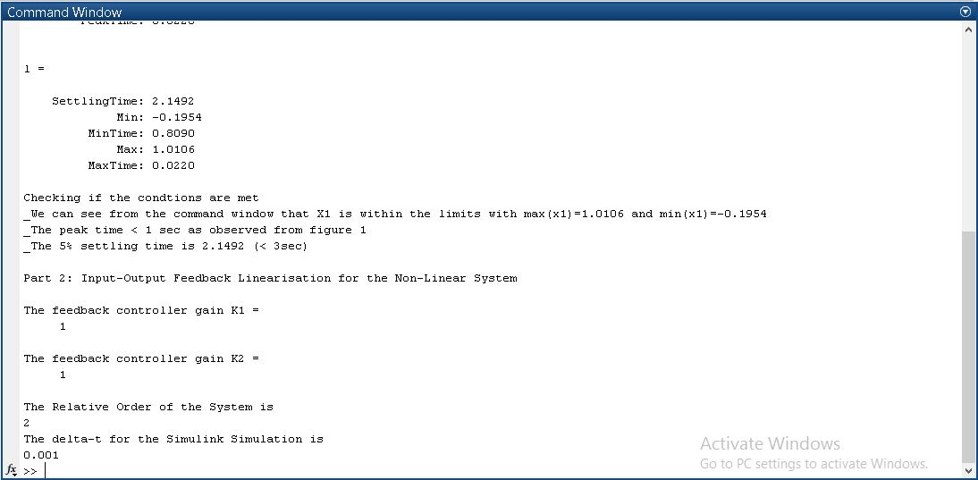

Figure 9: Command Window for Solutions for Questions 1 and 2

**Simulink Models**

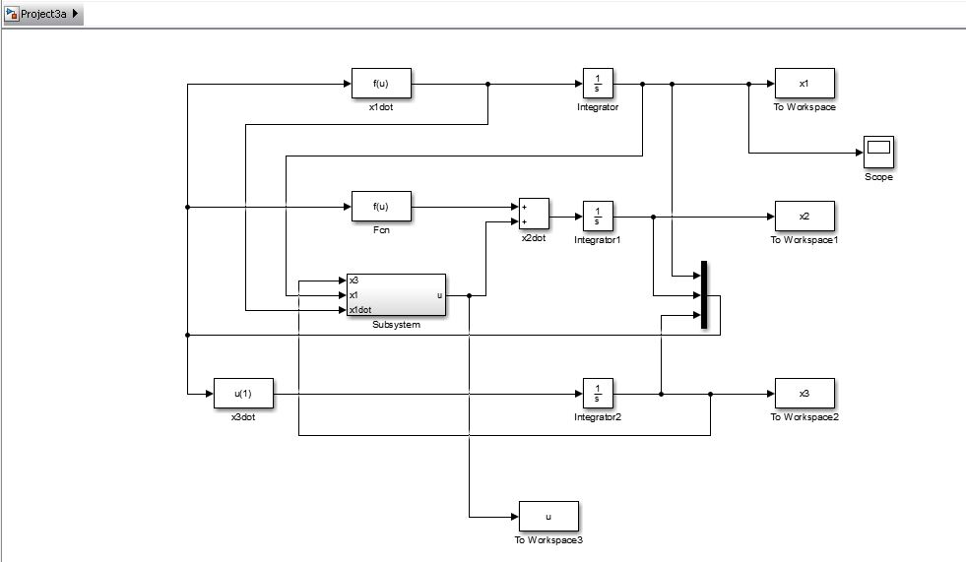

Figure 10: Simulink Model for Question 1 (Input- State Linearization)

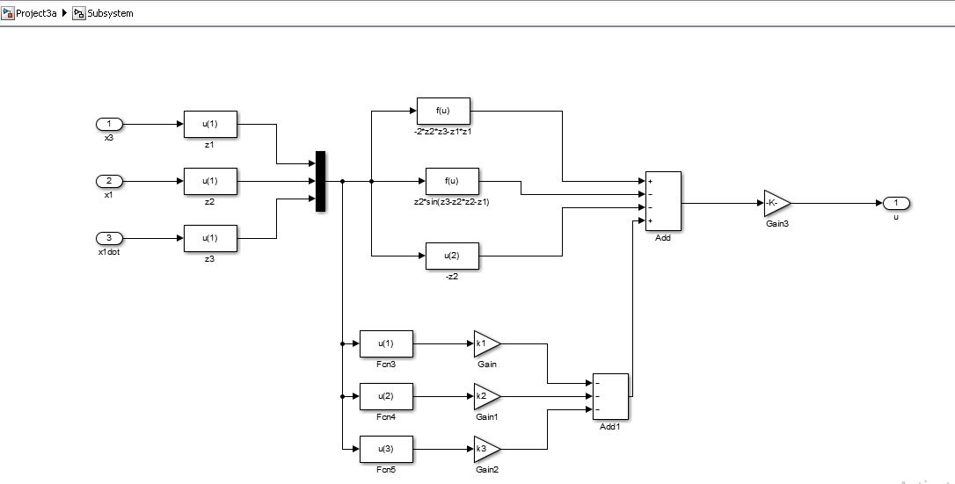

Figure 11: Simulink Subsystem Model for Question 1 (Input- State Linearization)

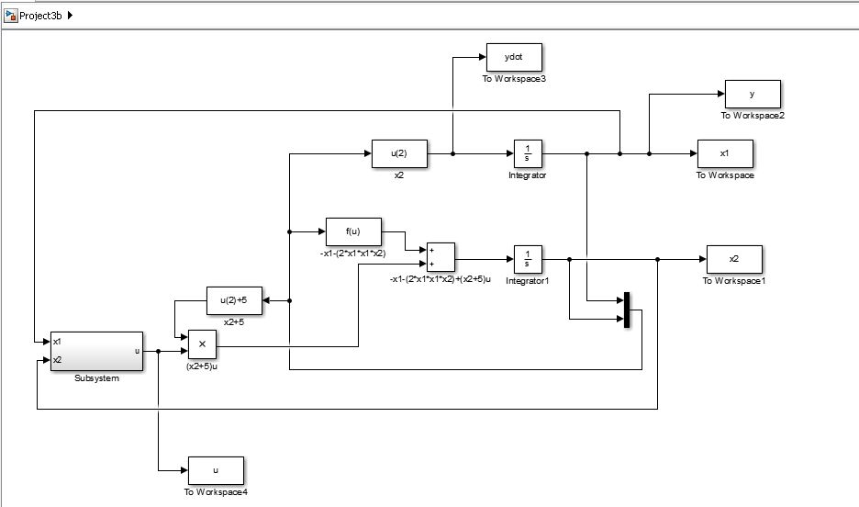

Figure 12: Simulink Model for Question 2 (Input- Output Linearization)

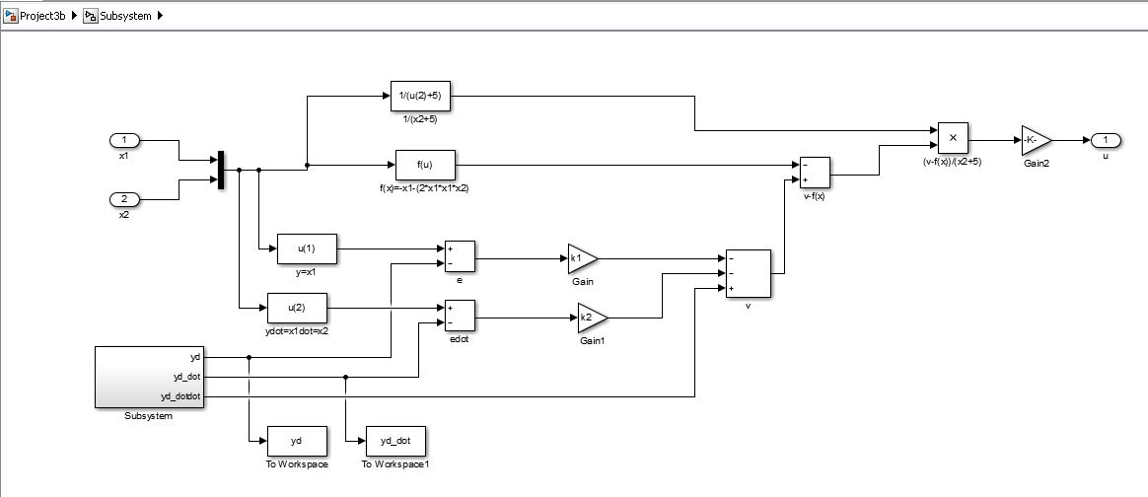

Figure 13: Simulink Subsystem Model for Question 2 (Input- Output Linearization)

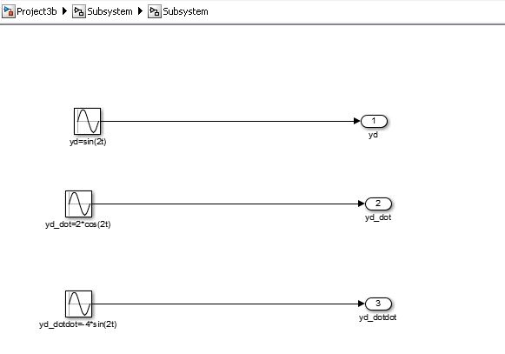

Figure 14: Simulink Subsystem inside Subsystem Model for Question 2 (Input- Output Linearization)

**MATLAB CODE**

%%Computer Project 3

%%Code by K S Adarsh Raj

%% Part 1: Input State Linearisation for the non Linear System

clear,clc;

disp('Part 1: Input-State Linearisation for the non Linear System')

fprintf(1,'\n') %%gives one line space

%define the ugain, the initial condtions and simulation time

ugain=1;

tf=6;

x10=1;

x20=0;

x30=0;

%define the controller gains

k1=30;k2=40;k3=10;

%display the controller gains

disp('The feedback controller gain K1 =')

disp(k1)

disp('The feedback controller gain K2 =')

disp(k2)

disp('The feedback controller gain K3 =')

disp(k3)

%display the delta-t for the Simulink simulation effort

disp('The delta-t for the Simulink Simulation is')

disp('0.001')

%call the simulation

sim('Project3a')

%Plot the graphs

figure(1),plot(tout,x1) %%Plotting X1 vs Time

grid on

axis([0 6 -0.25 1.2])

title('X1 Vs Time')

xlabel('Time (s)')

ylabel('X1')

figure(2),plot(tout,x2) %%Plotting X2 vs Time

grid on

title('X2 Vs Time')

xlabel('Time (s)')

ylabel('X2')

figure(3),plot(tout,x3) %%Plotting X3 vs Time

grid on

title('X3 Vs Time')

xlabel('Time (s)')

ylabel('X3')

figure(4),plot(tout,u) %%Plotting Controller Effort Vs Time

grid on

title('Controller Effort (U) Vs Time')

xlabel('Time (s)')

ylabel('U')

%% Checking if the condtions are met

s=stepinfo(x1,tout,'settling time',0.05)

l=lsiminfo(x1,tout,'settling time',0.05)

disp('Checking if the condtions are met')

disp('_We can see from the command window that X1 is within the limits with max(x1)=1.0106 and min(x1)=-0.1954')

disp('_The peak time < 1 sec as observed from figure 1')

disp('_The 5% settling time is 2.1492 (< 3sec)')

fprintf(1,'\n')

%% We can see from the command window that X1 is within the limits with max(x1)=1.0106 and min(x1)=-0.1954

%%The peak time < 1 sec as observed from figure 1

%%The 5% settling time is 2.1492 (< 3sec)

%%Part 2: Input-Output Feedback Linearisation for the Non-Linear System

disp('Part 2: Input-Output Feedback Linearisation for the Non-Linear System')

fprintf(1,'\n')

%define the ugain, the initial condtions and simulation time

ugain=1;

tf=10;

x10=0;

x20=2;

%define the controller gains

k1=1;

k2=1;

%display the controller gains

disp('The feedback controller gain K1 =')

disp(k1)

disp('The feedback controller gain K2 =')

disp(k2)

%display the relative order of the system

disp('The Relative Order of the System is')

disp('2')

%display the delta-t for the Simulink simulation effort

disp('The delta-t for the Simulink Simulation is')

disp('0.001')

%call the simulation

sim('Project3b')

%Plot the graphs

figure(5),plot(tout,y,tout,yd,'--') %Plotting Y&Yd Vs Time

grid on

title('Y & Yd Vs Time')

xlabel('Time (s)')

ylabel('Y,Yd')

legend('Y','Yd')

figure(6),plot(tout,ydot,tout,yd_dot,'--') %Plotting Ydot&Yddot Vs Time

grid on

title('Ydot & Yd-dot Vs Time')

xlabel('Time (s)')

ylabel('Ydot,Yd-dot')

legend('Ydot','Yd-dot')

figure(7),plot(tout,u) %Plotting Controller Effort (U) Vs Time

grid on

title('Controller Effort (U) Vs Time')

xlabel('Time (s)')

ylabel('U')